**AACS 1193 Wed Design and Development Assignment**

Selected Title: Online watch shop

Name of group members:

1. Lee Jun Jie

2.Ho Yung Harng

3. Kan Han Chin

4. Kelvin Yeoh Yong Jie

Tutorial Group: 1

Tutor’s name: Tan Lee Kent

Submission date: Week 7



**AACS1193 Web Design and Development**

**Semester 3, 2019/2020**

**Group Assignment**

|  |  |
| --- | --- |
| **Programme : Diploma in science(computer science and management mathematic )** | |
| **Tutorial Class : G1** | |
| **Website Title :** | |
| |  |  |  |  |  |  |  |  | | --- | --- | --- | --- | --- | --- | --- | --- | | **No.** | **Student Name** | **Student ID** | **Module In Charge** | **Signature** | **Part A**  **(25%)** | **Part B**  **(75%)** | **Total**  **(100%)** | | 1 | Lee Jun Jie | 19WMD02070 | Product, About Us |  |  |  |  | | 2 | Ho Yung Harng | 19WMD01530 | Home Page, Main Page, Brand |  | | 3 | Kan Han Chin | 19WMD00864 | Contact us, Store Location |  | | 4 | Kelvin Yeoh Yong Jie | 19WMD01695 | Cart,  FAQ |  | | |
| **Lecturer:** | **Tutor :**Tan Lee Kent |
| **Date of Submission:** Week 7 2/5/2020 | |

**Assessment Rubrics – Assignment Part 1**

|  |  |  |  |  |  |  |
| --- | --- | --- | --- | --- | --- | --- |
| Proposal (Phases of Planning & Designing Web)**Criteria** | **Marks** | **Excellent** | **Good** | **Average** | **Poor** | **Score** |
| **CLO 3: Manage the development of a Web site.** | | | | | | |
| Chapter 1 : Planning   * Description of the organization * Reasons of the Web site * Web site objectives * Potential users * Information the users need * Proposed deliverable | 8 | Excellently define all the required information.    (7 – 8) | Correctly define most of the required information.    (5 – 6) | Correctly define some of the information. The rest are either incorrect or missing.  (3 – 4) | Most of the information is missing, incomplete or incorrect.  (0 – 2) |  |
| Chapter 2: Web Analysis   * Functions or modules * Organization of the Web site | 6 | Excellently define all the required information.  (6 ) | Correctly define most of the required information.  (4 – 5) | Correctly define some of the information. The rest are either incorrect or missing.  (2– 3) | Most of the information is missing, incomplete or incorrect.  (0 – 1) |  |
| Chapter 3: Web Design   * Web page layout and elaboration | 8 | Excellently define all the required information.  (7 – 8) | Correctly define most of the required information.  (5 – 6) | Correctly define some of the information. The rest are either incorrect or missing.  (3 – 4) | Most of the information is missing, incomplete or incorrect.  (0 – 2) |  |
| Report Format   * References & Appendix | 3 | Excellently provide enough references and supporting documents  (3 ) | Correctly provide some references and supporting documents  (2) | Generally provide few references and supporting documents  (1 ) | Not able to provide enough references and supporting documents  (0 ) |  |
| **Total (25 marks)** | | | | | |  |

Comments (if any):

____________________________________________________________________________________________________________________________________________________________________________________________________________________________________________________________________________________________________________________________________

**Assessment Rubrics – Assignment Part 2 (Phases of Implementing Web)**

|  |  |  |  |  |  |  |
| --- | --- | --- | --- | --- | --- | --- |
| **Criteria** | **Marks** | **Excellent** | **Good** | **Average** | **Poor** | **Score** |
| **CLO 2: Demonstrate the web development using web development tool, Cascading Style Sheets (CSS) and JavaScript.** | | | | | | |
| **Functionality & Complexity of the Overall Web Site using the following elements:**   * Media elements (text, graphic, audio, video and animation) * Hypertext and hypermedia * List * Formatting * Hotspot / image map * Table * Form * CSS for all of the GUI design (use External Style Sheet effectively) * JavaScript | **40** | Excellently completed more than 80% of the required functionalities correctly using all the listed elements.    (31 – 40) | Completed more than 60% of the required functionalities correctly using most of the listed elements.    (21 – 30) | Averagely completed more than 40% of the required functionalities with some minor errors. Only used some of the listed elements.    (11 – 20) | Not able to complete most of the required functionalities correctly. Only used few of the listed elements.    (0 – 10) |  |
| **Creativity in Modules’ Function & Interface Design** | **15** | Excellent creativity in module function and interface design.  (13 – 15) | Good creativity in module function and interface design.  (9 – 12) | Average creativity in module function and interface design.  (5 – 8) | Poor creativity in module function and interface design.  (0 – 4) |  |
| **User Interface Features** | **15** | Excellent design consistency and interface usability, visual effect and interactivity.  (13 – 15) | Good design consistency and interface usability, visual effect and interactivity.  (9 – 12) | Average design consistency and interface usability, visual effect and interactivity.  (5 – 8) | Poor design consistency and interface usability, visual effect and interactivity.  (0 – 4) |  |
| **Web Site Consistency with Part 1 (Students are required to justify if there is any inconsistency)** | **5** | Excellent consistent with proposed design.  (5) | Good consistent with proposed design.  (4) | Average consistent with proposed design.  (2 – 3) | Poor consistent with proposed design.  (0 – 1) |  |
| **Total (75 marks)** | | | | | |  |

Comments (if any):

____________________________________________________________________________________________________________________________________________________________________________________________________________________________________________________________________________________________________________________________________

**Plagiarism Statement**

The university college views cases of plagiarism or collusion by students very seriously. Any students who intentionally plagiarize of collude in any part of their assignments/projects or written work threatens the values of academic work and undermines the credibility and integrity of the University College’s awards. Plagiarism or collusion discovered at any stage of the student’s course of study will be dealt with appropriately by the School. Such offender shall appear before a panel of enquiry at the School and appropriate punishment will be meted out. Punishment may include failing the student for the assignment or project, re-submission of another piece of work or downgrading of the work the maximum of a pass grade even if actual grade achieved was higher.

**What constitutes “Plagiarism” and “Collusion”?**

Plagiarism according to the Oxford Advanced Learner’s Dictionary of Current English

means “take and use somebody else’s ideas, words, etc as if they were one’s own.”

**Plagiarism**

can take the form of reproduction without acknowledgement from published or unpublished

works of others including materials download from computer files an Internet.

Student’s work submitted for assessment is accepted on understanding that it is the

students’ own effort without falsification of any kind. Acknowledgement to the source must

be made if students had replied on any sources for information with appropriate reference

being made in their work.

**Collusion** can be deemed to be a form of plagiarism involving the unauthorized co

operation between two or more people with deceptive intention.

Collusion can take the form of two or more students producing a piece of work together but

one intentionally passing it off as his work with the knowledge of the others. Student may

have submitted the work of another as his own with consent from that other student. In such

cases, both parties are guilty of collusion.

**Obligations of students**

Students are required to sign a declaration that the work submitted such as course work

assignment, essays and projects, etc is their own work and that they have not in any way

knowingly allow another student copy it. It will be assumed that all submitted work is that of

the students’ own work.

Students are expected to familiarize themselves with or make use of method(s) of citing

other people’s work in accordance with acceptable referencing



**AACS1193 Web Design and Development**

**Plagiarism Statement Form**

**We confirm that the submitted work are all our own work and are in our own words.**

|  |  |  |
| --- | --- | --- |
| **Name (Block Capitals)** | **Student ID** | **Signature** |
| Lee Jun Jie | 19WMD02070 |  |
| HO YUNG HARNG | 19WMD01530 |  |
| Kan Han Chin | 19WMD00864 |  |
| Kelvin Yeoh Yong jie | 19WMD01695 |  |

|  |  |
| --- | --- |
| Tutorial Group |  |
| DATE |  |

Part 1-Proposal (Phases and Planning & Designing Web)

Chapter 1- Planning

1. Description of the organization

-Our organization are selling multiple type of watches to allow customer to buy watches online. It will reduce more time by purchasing it online than going to a watch shop.

2. Justification/reasons for developing the website

-To allow user to search for the watches they want easily instead of looking around in a watch shop.

3. Website Objectives

-The main objectives of our website is to promote and sell product. Our website will also provide information about the watch that we are selling, this allow customer to know the detail of the watches and also allow customer to order from our website easily. Other than that, our website will also the show the full detail of the watches such as price, brand and feature of the watch. Furthermore, the customer are able to buy the watch they wanted via our website. They will be able to see the watch they added into the cart and also the way they want to ship the watch to them and also the total price of all the watches they pick. Moreover, this website will have customer service that allow user to email or contact us and also a FAQ function allow user to review all the common question that will be ask my our customer.

4. Potential users of the website

- Customer who are interest on purchasing watch online.

- Customer who want to know more about the details of these watch

5. Information users need and want

-Price

-Brand

-Detail

-Contact number

-Email address

6. Proposed deliverable of the final web site (need to include all the activities and duration involved)

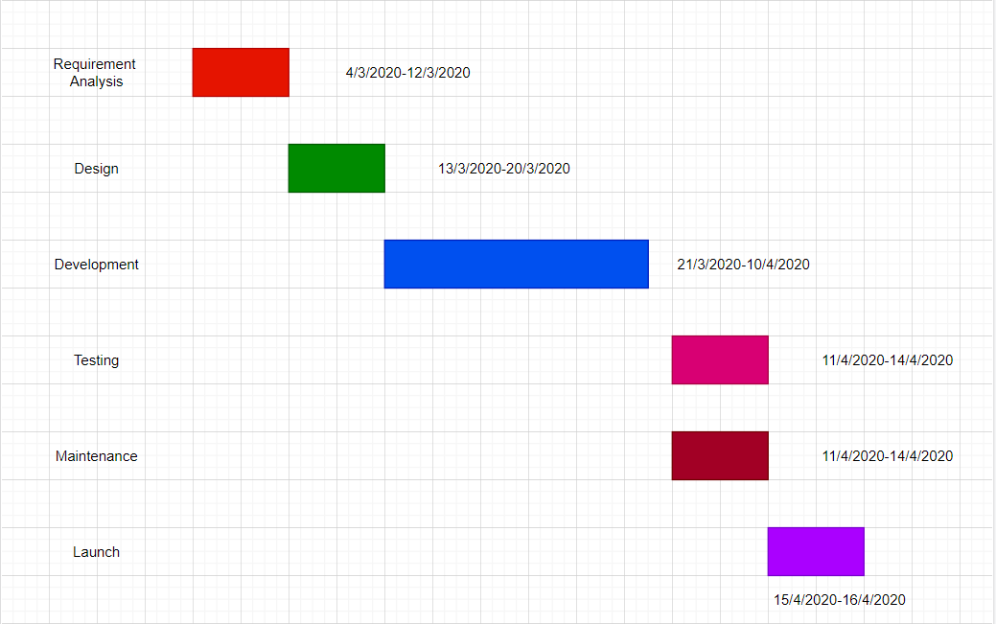

Chapter 2 – Web Analysis

**Function**

-Homepage

(This is the first page where we will show a brief of Vision Watch collection.)

-Mainpage

(This page will show two option for customer to choose which are men watch or women watch.)

-Collection

(This is the page after users choose either men or women. It will show multiple logo of watches for user to choose such as Rolex, G-shock, AudemarsPiguet, Hublot and Richard Millie.)

-Product

(This is the page after users decide which brands they want to choose. It will show a slideshow of different type of watches of the brand. Below the slideshow will show all the category of watches with the price and details of the watches and also a button which allow user add the following watches to the cart in order to purchase the watches.)

-About us

(This is the page mainly talking about the background of our company and also the team member.)

-FAQ

(This is the page that allow user to review all the common question that will be frequently asked by the customer. User are able to review the question and answer that we reply in this FAQ page.)

-Cart

(This is the page that allow user to review all the watches that they add to the cart and it will also show the total price of the watches they added in the cart.)

-Contact us

(This is the page that show our organization email and also the contact number. Moreover, customer are able to submit their feedback about this website in this page.)

-Store Location

(This is the page that show all the store location that we have around Malaysia and the contact number in this page. It allow user to know better about the watch they want to buy.)

**Organization of web site**

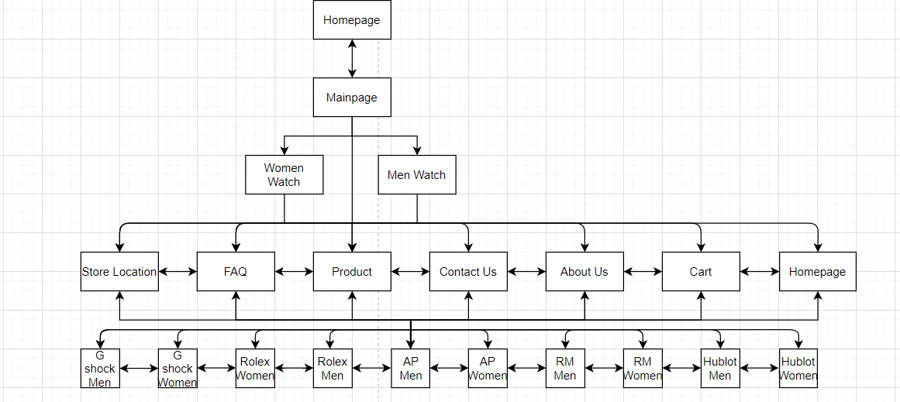

**Appendix 1**

**HOME PAGE (Ho Yung Harng)**

As shown in figure 1 below, this is the homepage which consists of a logo of our organization, a navigation bar which include of hypertext link, such as about us, FAQ, contact us, store location and cart. Below of the navigation bar, there is 5 different type of watch logo just to let users know that we are selling these 5 brand of watches in our website. Other than that, there is a logo of our organization which also it’s a hypertext link which allow user to proceed to the main page after clicking it.

|  |
| --- |
| C:\Users\Home\Downloads\WhatsApp Image 2020-04-29 at 4.26.24 PM.jpeg |

Figure 1

**Appendix 2**

**MAIN PAGE (Ho Yung Harng)**

As shown in figure 2 below, this is the main page which has two option for user to choose which is either boys watch or girls watch.

|  |
| --- |
| C:\Users\Home\Downloads\9b71b700-6a9b-4402-af34-ec67859b1a40.jpg |

Figure 2

**Appendix 3**

**BRANB (Ho Yung Harng)**

Figure 3 is show the brand to let the customer to choose which brand need to purchases. Brand Women and Men web page design is a same design. When Customer to click the Button will go in the product collection.

|  |
| --- |
| C:\Users\Home\Downloads\WhatsApp Image 2020-04-29 at 4.26.25 PM (1).jpeg |

Figure 3

Appendix 4

Product

This is the page that user will shop in the website after they choose either boys or girls and the brand they want. It will show a slideshow of some special watches of the brand and below the slideshow it will show all the watches that we are selling. User are able to hover to the watch and it will show the detail and the price of the watch in the picture. The add to cart button is also below the picture of the watch. So it allow user to add the following watch to their cart in order to purchase it.

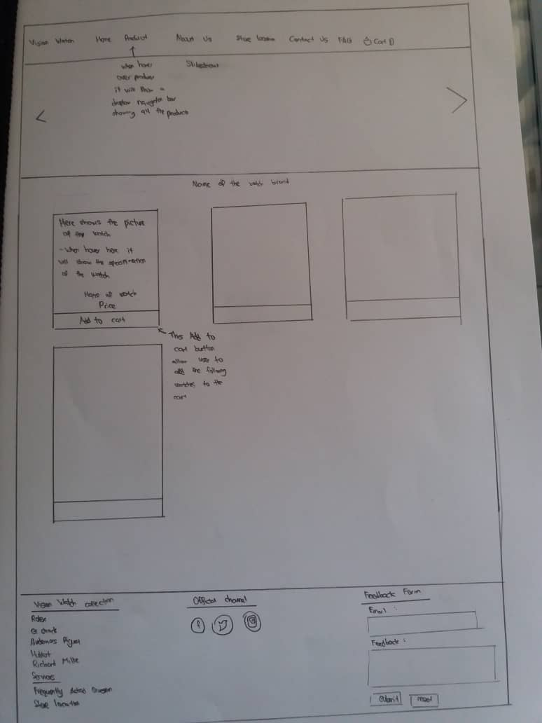

Figure 4

Appendix 5

About Us

This page only have a description about our organization and also the name and picture of the team member.

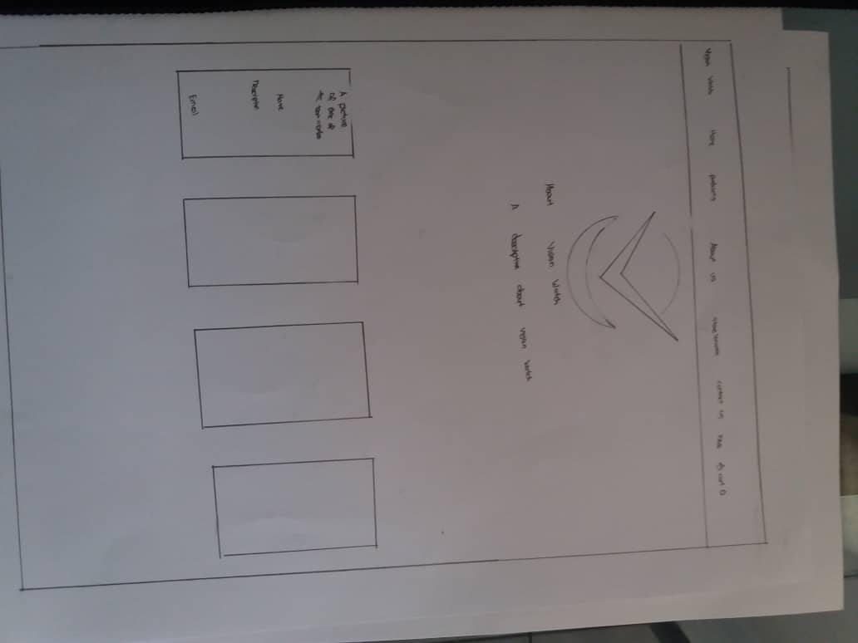

Figure 5

**Appendix 6**

This is the page that allow user to review all the common question that will be frequently asked by the customer. User are able to review the question and answer that we reply in this FAQ page.

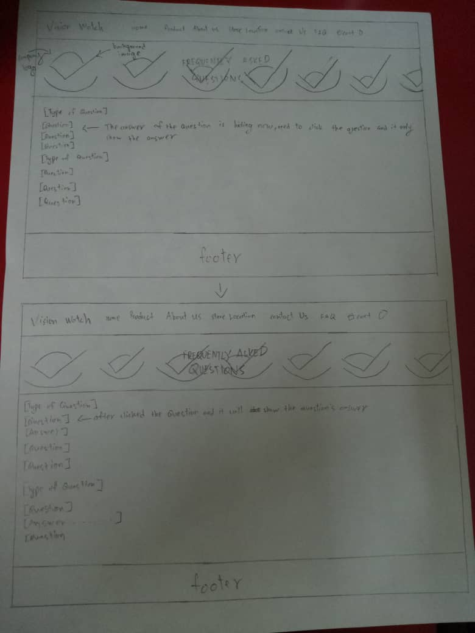

Figure 6

**Appendix 7**

This is the page that allow user to review all the watches that they add to the cart and it will also show the total price of the watches they added in the cart.

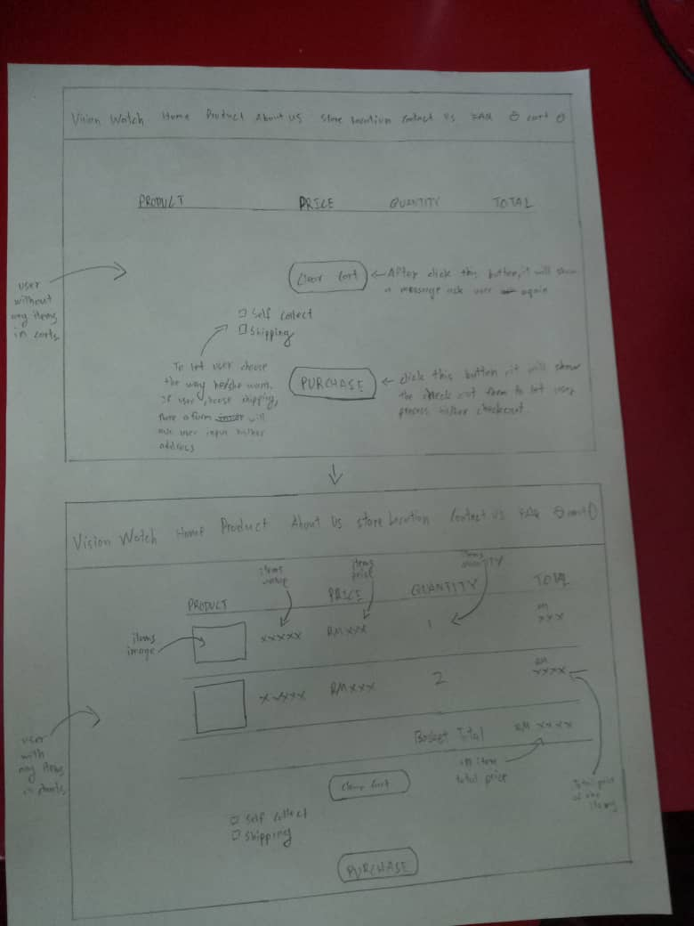

Figure 7

Appendix 8

This is contact us page and store location page. For contact us page, user can complain any problem that they met on our website. User need to enter their information then they only can submit their feedback. Besides that, user also can straight away contact us by call or email us too.

For the store location page, user can check where is the shop of brands that work with us. So that they can go to the shop to repair their watch. User also can find the model that didn’t sell in our website there.

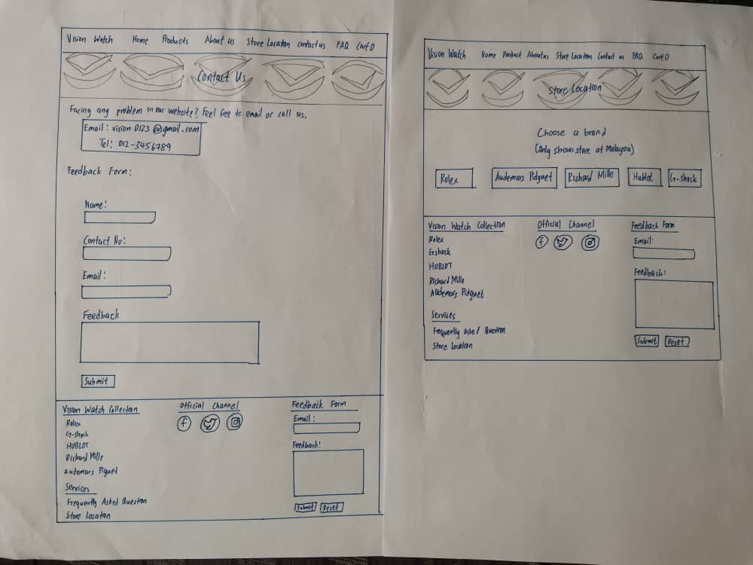

Figure 8

References

-W3schools.com. 2020. *W3schools Online Web Tutorials*. [online] Available at: <https://www.w3schools.com/> [Accessed 1 May 2020].